
QUALITY ALERT

Customer: ChamClad Date: May 6, 2025
Die: 15766-16016C Colour: Any
Type of Complaint: ChamClad REJECTED

Q.A # 25-002 NCR #: 053

Description: ChamClad REJECTED – Punch too close to the edge so the screw does not sit flush in channel and panels cannot slide together properly.
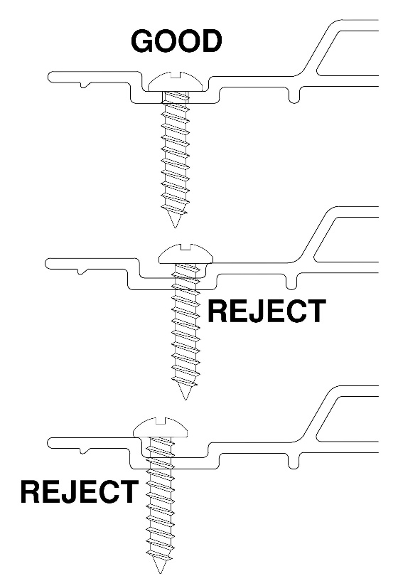
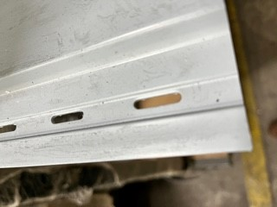
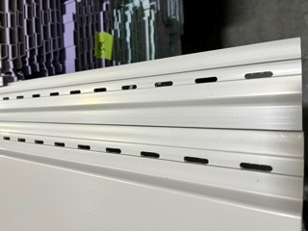

BY SIGNING BELOW, YOU ACKNOWLEDGE THE PROBLEM ABOVE AND AGREE TO MONITOR THIS ISSUE IN FUTURE PRODUCTION RUNS.
DAY SHIFT |  | AFTERNOON SHIFT |  | NIGHT SHIFT
NAME | SIGNATURE | NAME | SIGNATURE | NAME | SIGNATURE
F-006: Quality Alert | Eff.Date: 05/03/2025 | CC# 25-046 | Rev.0

